

*shell programming lab*

aSsignment -8

**SUBMITTED BY: SUBMITTED TO:**

**AYUSH KUMAR JHA Dr. Dhiviya Rose**

**SAP ID - 500086400**

**Enrollment no - R200220083**

**B.C.A -I.O.T.**

**EXPERIMENT – 10**

**TITLE:** Shell Scripts implementing Looping Structure

**Activities:**

1. Write a shell that demonstrates the use of logical operators in shell programming.

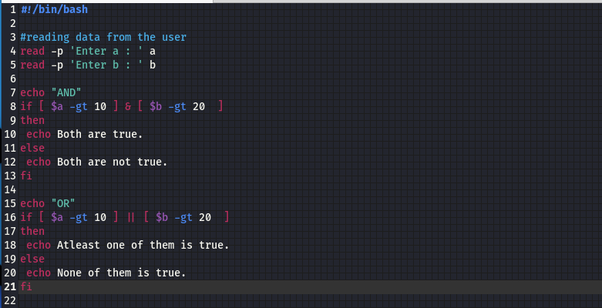

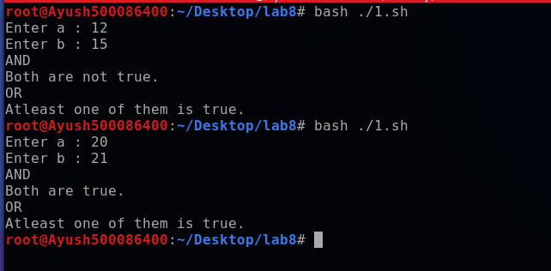

2. Write an algorithm and appropriate shell script to compute the factorial of a number entered by the user.

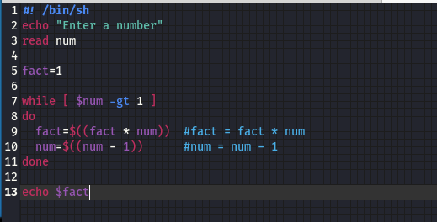

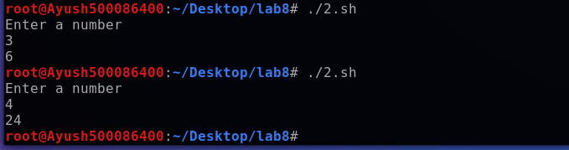

3. Generate the Fibonacci series for an integer entered by the user.

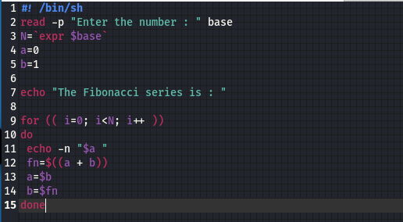

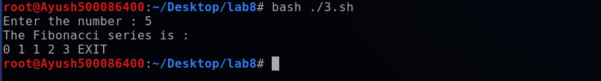

4. Draw Pascal’s Triangle.

